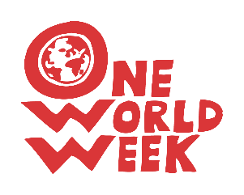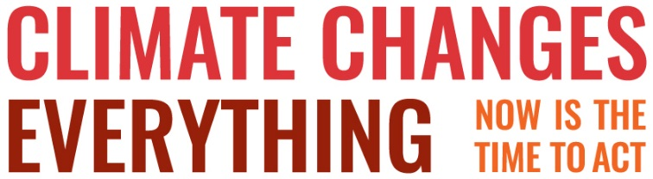

DRAMA

Planet Doctor – a humorous story/dramatic sketch. Time: 6 – 8 minutes
Cast and setting
PD = Planet Doctor (sits behind a desk, wearing white coat)
Nurse (non-speaking) = appears with Earth’s medical records, then shows Earth into the Doctor’s surgery
E = Earth (padded out to be as rotund as possible!)
PD: The earth. Give me her file nurse.
Thank you. Yes, right. (looking at a file)
Four thousand six hundred million years old. Quite young for a planet.
Ah! What’s this?
A hundred thousand years ago. Signs of human life.
That’s worrying.
Air, water. Yes, good. Plants. Yes good.
Extinction of dinosaurs. Mmmm.
Oh! Flu like symptoms:
Warm and sweaty for long periods, then freezing cold.
Show the patient in, nurse. (nurse ushers Earth in)
PD: Good morning. Take a seat.
E: Oh! I can’t sit down doctor, far too painful.
PD: We’d better stand up then.
You’ve been losing weight, I gather.
E: Oh, Yes doctor, it’s awful.
Me coal and gas and oil are getting really low.
PD: That’s obviously due to too much liposuction.
Too much being drawn out,
You can’t take millions of years to build these things up and then remove them all in a couple of centuries.
We’ll have to do something to slow that down.
But then you’ve had all this radical surgery!
E: Oh yes doctor. It’s been so painful,
That’s why I can’t sit down. All these painful scars.
It’s been 250 years, and they’ve only just got round to sending me to you.
And I’m feeling so hot all the time.
PD: Yes, you will be.
That’s because of all the extra carbon dioxide you’re breathing, from the burning of all that coal, oil and gas.
E: Ooh! And I get these storms doctor, raging storms and floods,
And then these terrible droughts,
And me sea levels rising something shocking!
PD: Yes, the prognosis is pretty grim actually,
And you’re seriously addicted to oil burning aren’t you? If we don’t wean you off that the fever could be fatal.
E: Ooh! I hope you can doctor I already have such terrible trouble breathing.
PD: Trouble breathing you said?
E: Ooh, yes doctor. I wheeze like a black hole at times.
PD: That’s because you’re losing your forests.
I’ll have to prescribe trees. High doses of tree planting.
I mean, looking at these notes, this problem’s been increasing for 5000 years,
But in this last six hundred or so, it’s got rapidly worse.
You’ll soon have no fresh air at all.
E: I get this terrible itching too, doctor.
PD: Humans. That’s humans, swarming all over you.
Most of your problems start with humans.
E: You mean like all these wars I’ve got? Ooh! They’re really painful!
And then there’s me water retention, and me circulation problems.
PD: Yes, I can see your seas rising,
And your dry areas getting more and more arid,
But then there’s your temperate zones.
E: Me temperate zones, doctor? What’s wrong with me temperate zones?
PD: More and more rain, increasing vulnerability to flooding. Things are not good, Mrs. Earth, not good at all.
E: And just recently, doctor, I’ve noticed all this plastic accumulating in me oceans, killing me lovely sea birds and fish – makes me feel sick and depressed.
PD: I’m afraid that’s down to your humans, too, making stuff you can’t process and overloading your digestive system. But what’s this about being depressed?

E: I’m sad cos some of me favourite birds and animals seem to be disappearing - hardly see any tigers or orangutans these days, or me funny little puffins and penguins. I really miss them.

PD: It’s your humans again – they’re destroying the homes of your tigers and orangutans so they can grow food for factory-farm animals producing meat for humans to eat. And that accounts for the loss of puffins and penguins too – trawling up the little fish they like to eat and leaving them starving.

PD: You’ve got an acute halitosis problem as well.
E: I’ve been worried about that for two hundred years doctor.
PD: It’s your air pollution.
Humans again. Oh! Yes. Industrial revolution - Damaged living organisms,
Including your humans, with asthma and lung disease,
Not to mention damage to buildings.
E: Oh! Dear. It sounds awful.
And Ooh doctor just look at me ozone layer!
PD Yes, it’s very thin. It could possibly right itself.
But we can’t make that assumption.
And your humans are going to get more fatal skin cancers
And problems with cataracts.
E: What’s your verdict Doctor?
Is there any hope for me at all?
PD: Well, Mrs. Earth I don’t want to give you any false hopes.
I have to say that you are suffering from an unsustainable growth in your human species.
If your current human activity doesn’t change, I’m afraid your ailments could prove terminal for the balance of planetary life.
E: Ooh! Doctor! What are we going to do?

Alan Gaunt, hymn writer and member of Parkgate and Neston United Reformed Church, adapted material from Eco-congregation Module 2 into a sketch which was used as part of their Harvest Festival. With a 2018 addition (on plastic) and a 2019 addition (on species extinction) from OWW.

